## Unit 11 Submission File: Network Security Homework

### Part 1: Review Questions

#### Security Control Types

The concept of defense in depth can be broken down into three different security control types. Identify the security control type of each set of defense tactics.

1. Walls, bollards, fences, guard dogs, cameras, and lighting are what type of security control?

Answer: Physical

2. Security awareness programs, BYOD policies, and ethical hiring practices are what type of security control?

Answer: Administrative

3. Encryption, biometric fingerprint readers, firewalls, endpoint security, and intrusion detection systems are what type of security control?

Answer: Technical

#### Intrusion Detection and Attack indicators

1. What's the difference between an IDS and an IPS?

Answer: reactive vs proactive. An IDS sits on the perimeter of a network on a mirrored port or TAP and is not in-line with the traffic entering the network. Based upon the rules set it will generate alerts of varying levels but will not affect the flow of traffic in any way.
An IPS is inline, typically between the firewall and internal network. Based upon the rules set it will not only generate alert or event logs, but also has the capability to prevent certain types of traffic. One is passive whereas the other is active and responsive in terms of the ability to block traffic.

2. What's the difference between an Indicator of Attack and an Indicator of Compromise?

Answer: IOA involves known and documented types of attacks in terms of objective and method, typically based upon known signatures. IOA functions in real-time. It relies upon information about attacks that have already been identified. Thus an attack that wouldn’t trigger malware warnings (os vulnerabilities, living off of the land, etc) could still be flagged as anomalous behavior within or upon a network and investigated and/or prevented preemptively.
IOC determines what has occurred within a network following a successful attack, diagnoses the changes to any affected systems, and is used to react to a successful breach by allowing for damage control and vulnerability mitigation. This is a reactive approach.
Essentially IOA is like ducking in time and IOC is like sticking a bandaid to your bleeding forehead.

#### The Cyber Kill Chain

Name each of the seven stages for the Cyber Kill chain and provide a brief example of each.

1. Stage 1: Reconnaissance- gathering info about a target. Broadly scanning networks, dumpster diving, peeking through windows, intercepting PII, etc. Seems mostly automated these days, with tools and frameworks configurable to search for attacker defined vulnerabilities using methods ranging from extreme and fast to lengthy and stealthy.

2. Stage 2: Weaponization- using the intel gathered in step 1 the attacking agent will develop a plan based on said information that will best circumvent or nullify the security measures implemented by their target during the process of carrying out their attack.

3. Stage 3: Delivery- this stage is exactly what it sounds like. based upon the two previous steps attackers have gone through they will decide upon a method in which to deliver their payload. it could be through phishing, leaving usb drives laying around, LALO parachuting onto the top of a large building and using a thermal lance to cut their way through the roof and into the server room in order to plug in a commodore-64 and install a malicious version of tic-tac-toe that triggers nuclear missile launches. whichever method best ensures the success of their objective.

4. Stage 4: Exploitation- at this point the attacker is within the network. now the fun starts, as they begin altering administrative rights and modifying system settings using OS vulnerabilities. Adjusting event log rules, configuration files, security certificates, running scripts, and so forth.

5. Stage 5: Installation- at this stage the attacker typically installs a backdoor or RAT for continued unencumbered access to the system/network.

6. Stage 6: Command and Control- The attacker is now attempting to gain ultimate control over the network by gaining access to admin accounts, changing privileges, permissions, and credentials. This step also sounds like the title of a bad industrial album.

7. Stage 7:Actions on objective- just as it sounds, the attacker carries out their objective through the actions they take. stealing data, breaking stuff, etc.

#### Snort Rule Analysis

Use the Snort rule to answer the following questions:

Snort Rule #1

```bash
alert tcp $EXTERNAL_NET any -> $HOME_NET 5800:5820 (msg:"ET SCAN Potential VNC Scan 5800-5820"; flags:S,12; threshold: type both, track by_src, count 5, seconds 60; reference:url,doc.emergingthreats.net/2002910; classtype:attempted-recon; sid:2002910; rev:5; metadata:created_at 2010_07_30, updated_at 2010_07_30;)
```

1. Break down the Sort Rule header and explain what is happening.

Answer: the header is alerting about a tcp packet inbound from network $external_net, any port, to $home_net, ports 5800 through 5820. this generated an alert because of how snort has been configured, presumably something to do with ET VNC scans.

2. What stage of the Cyber Kill Chain does this alert violate?

Answer: Recon

3. What kind of attack is indicated?

Answer: attempted-recon. reference emergingthreats.net/2002910

Snort Rule #2

```bash
alert tcp $EXTERNAL_NET $HTTP_PORTS -> $HOME_NET any (msg:"ET POLICY PE EXE or DLL Windows file download HTTP"; flow:established,to_client; flowbits:isnotset,ET.http.binary; flowbits:isnotset,ET.INFO.WindowsUpdate; file_data; content:"MZ"; within:2; byte_jump:4,58,relative,little; content:"PE|00 00|"; distance:-64; within:4; flowbits:set,ET.http.binary; metadata: former_category POLICY; reference:url,doc.emergingthreats.net/bin/view/Main/2018959; classtype:policy-violation; sid:2018959; rev:4; metadata:created_at 2014_08_19, updated_at 2017_02_01;)
```

1. Break down the Sort Rule header and explain what is happening.

Answer: alerts to tcp traffic from $http_ports inbound to $home_net any port. the alert rule was triggered by a download which may or may not be malicious, but is against the policy set in snort.

2. What layer of the Defense in Depth model does this alert violate?

Answer: Administrative, as it is flagged due to a policy violation
source: http://zentekconsulting.com/solutions/enterprise-security-solutions/data-security/

3. What kind of attack is indicated?

Answer: None. There is no indication that this is necessarily an attack rather than a policy violation. nonetheless it should be investigated as it seems suspicious. If it were an attack it would be designated as delivery within the cyber kill chain model. view emergingthreats.net/bin/view/Main/2018959

Snort Rule #3

- Your turn! Write a Snort rule that alerts when traffic is detected inbound on port 4444 to the local network on any port. Be sure to include the `msg` in the Rule Option.

Answer: alert tcp $EXTERNAL_NETWORK 4444 -> $LOCAL_NETWORK any (msg: ”ET POLICY TROJAN POSSIBLE W32.BLASTER.WORM”
https://www.speedguide.net/port.php?port=4444

### Part 2: "Drop Zone" Lab

#### Log into the Azure `firewalld` machine

Log in using the following credentials:

- Username: `sysadmin`
- Password: `cybersecurity`

#### Uninstall `ufw`

Before getting started, you should verify that you do not have any instances of `ufw` running. This will avoid conflicts with your `firewalld` service. This also ensures that `firewalld` will be your default firewall.

- Run the command that removes any running instance of `ufw`.
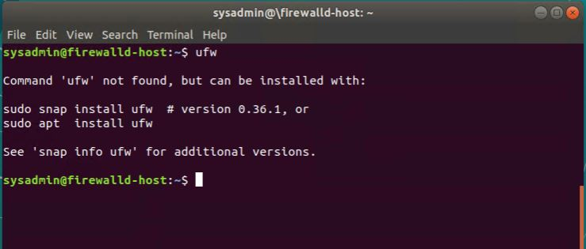
UFW is not installed on the firewalld machine
```bash
$ sudo apt-get remove ufw (if it had in fact been installed)
```

#### Enable and start `firewalld`
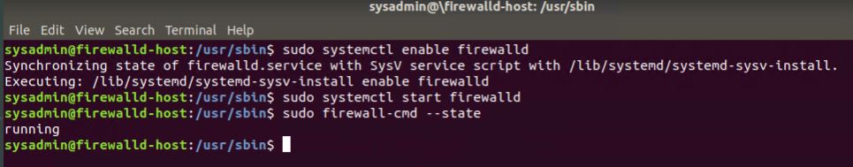
By default, these service should be running. If not, then run the following commands:

- Run the commands that enable and start `firewalld` upon boots and reboots.

```bash
$ sudo systemctl enable firewalld
$ sudo systemctl start firewalld
```

Note: This will ensure that `firewalld` remains active after each reboot.

#### Confirm that the service is running.

- Run the command that checks whether or not the `firewalld` service is up and running.

```bash
$ sudo firewall-cmd --state
```

#### List all firewall rules currently configured.

Next, lists all currently configured firewall rules. This will give you a good idea of what's currently configured and save you time in the long run by not doing double work.

- Run the command that lists all currently configured firewall rules:

```bash
$ sudo firewall-cmd --list-all
```

- Take note of what Zones and settings are configured. You many need to remove unneeded services and settings.

#### List all supported service types that can be enabled.

$ sudo firewall-cmd --get-services
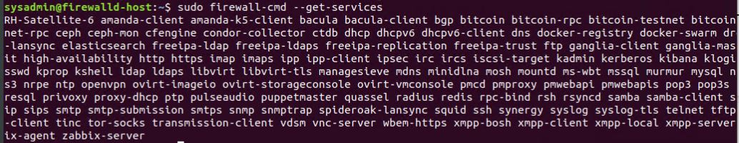
This shows all services that can be enabled

- Run the command that lists all currently supported services to see if the service you need is available

$ sudo firewall-cmd --list-services
```
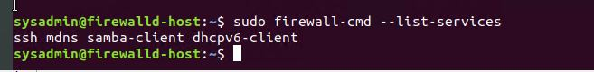
This shows which services are currently enabled
- We can see that the `Home` and `Drop` Zones are created by default.

#### Zone Views

- Run the command that lists all currently configured zones.

```bash
$ sudo firewall-cmd --list-all-zones
```
I’m choosing not to insert several large screenshots here that you’ll pretty much end up seeing later in the homework anyway. hope ya don’t mind.

- We can see that the `Public` and `Drop` Zones are created by default. Therefore, we will need to create Zones for `Web`, `Sales`, and `Mail`.

#### Create Zones for `Web`, `Sales` and `Mail`.

- Run the commands that creates Web, Sales and Mail zones.

```bash
$sudo firewall-cmd --permanent --new-zone=Web
$sudo firewall-cmd --permanent --new-zone=Sales
$sudo firewall-cmd --permanent --new-zone=Mail
$sudo firewall-cmd --reload (this in order for new zones to take effect)
#### Set the zones to their designated interfaces:

- Run the commands that sets your `eth` interfaces to your zones.
```bash
$ sudo firewall-cmd --zone=public --change-interface=eth0
$ sudo firewall-cmd --zone=Web --change-interface=eth1
$ sudo firewall-cmd --zone=Sales --change-interface=eth2
$ sudo firewall-cmd --zone=Mail --change-interface=eth3
```
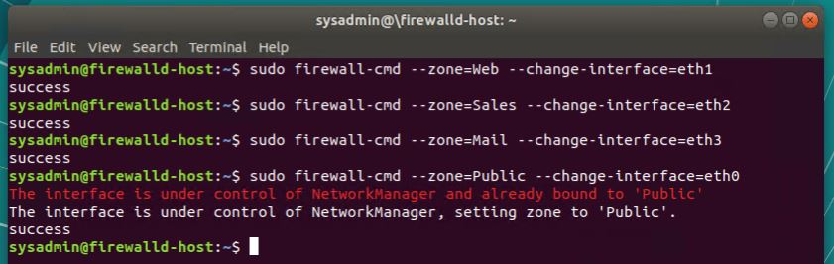
(Spoiler Alert: I just made the mistake that would cost me hours of frustration)
#### Add services to the active zones:

- Run the commands that add services to the **public** zone, the **web** zone, the **sales** zone, and the **mail** zone.

- Public: (and all the rest)

```bash
$sudo firewall-cmd --zone=public --add-service={http,https,pop3,smtp}
$ sudo firewall-cmd --zone=Web --add-service=http
$ sudo firewall-cmd --zone=Sales --add-service=https
$ sudo firewall-cmd --zone=Mail --add-service={smtp,pop3}
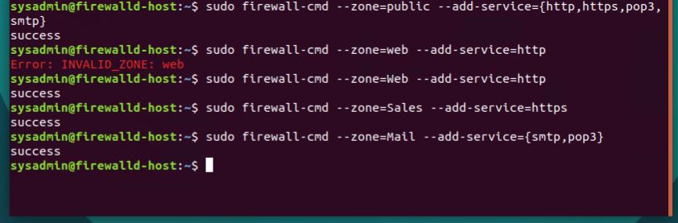
```

- What is the status of `http`, `https`, `smtp` and `pop3`?

Http, Https, Smtp, and pop3 are enabled

#### Add your adversaries to the Drop Zone.

- Run the command that will add all current and any future blacklisted IPs to the Drop Zone.

```bash
$ firewall-cmd --permanent --zone=drop source=10.208.56.23
$ firewall-cmd --permanent --zone=drop source=76.34.169.118
$ firewall-cmd --permanent --zone=drop source=135.95.103.76
```

#### Make rules permanent then reload them:

It's good practice to ensure that your `firewalld` installation remains nailed up and retains its services across reboots. This ensure that the network remains secured after unplanned outages such as power failures.

- Run the command that reloads the `firewalld` configurations and writes it to memory

```bash
$ sudo firewall-cmd --reload
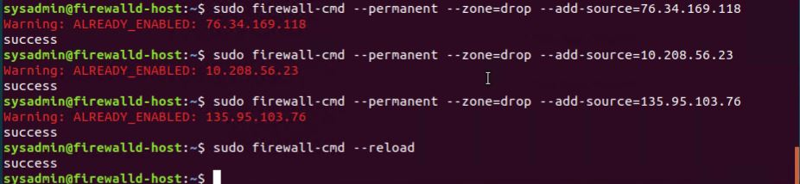

#### View active Zones

Now, we'll want to provide truncated listings of all currently **active** zones. This a good time to verify your zone settings.

- Run the command that displays all zone services.

```bash
$ sudo firewall-cmd --get-active-zones
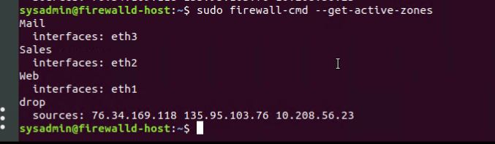
```

#### Block an IP address

- Use a rich-rule that blocks the IP address `138.138.0.3`.
$ sudo firewall-cmd --permanent --add-rich-rule=’ rule family=”ipv4” source address=”138.138.0.3” reject’ 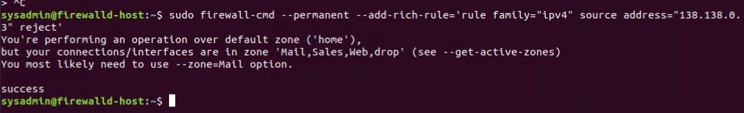
(again, this little snafu gets fixed towards the end)
#### Block Ping/ICMP Requests

Harden your network against `ping` scans by blocking `icmp ehco` replies.

- Run the command that blocks `pings` and `icmp` requests in your `public` zone.

```bash
$ sudo firewall-cmd --zone=public --add-icmp-block=echo-reply --add icmp-block=echo-request
(i realize the command above isn’t quite right. thank goodness for the next section!)

#### Rule Check

Now that you've set up your brand new `firewalld` installation, it's time to verify that all of the settings have taken effect.

- Run the command that lists all of the rule settings. Do one command at a time for each zone.

```bash
$ sudo firewall-cmd --zone=public --list-all
$ sudo firewall-cmd --zone=home --list-all
$ sudo firewall-cmd --zone=Mail --list-all
$ sudo firewall-cmd --zone=Sales --list-all
$ sudo firewall-cmd --zone=Web --list-all

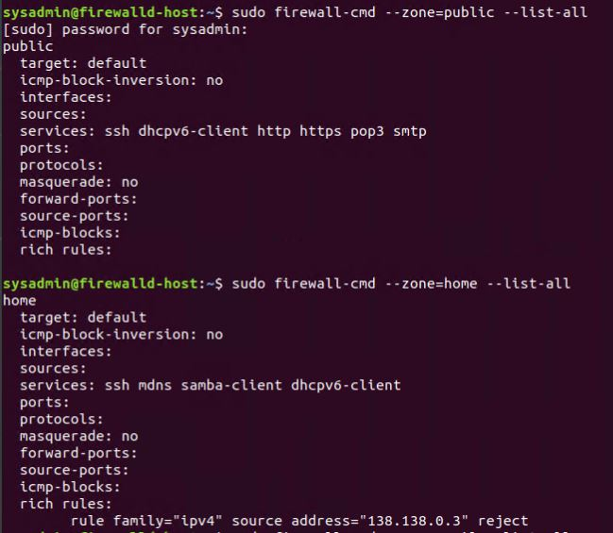
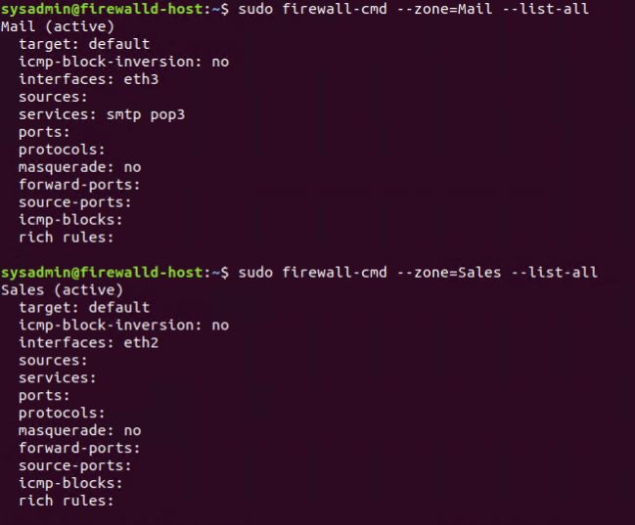
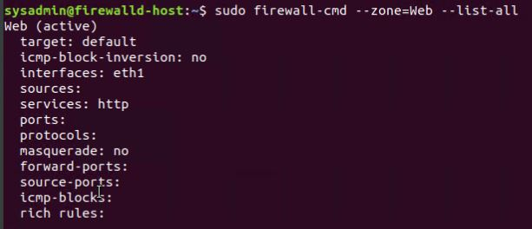

- Are all of our rules in place? If not, then go back and make the necessary modifications before checking again.

Hmmm… Wasn’t there supposed to be an ICMP Block in the public zone? Let’s see what’s going on here.
$ sudo firewall-cmd --query-icmp-block=echo-request
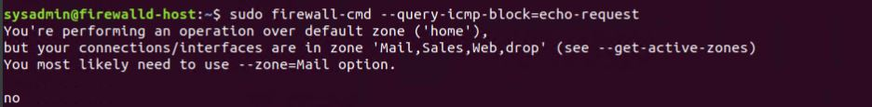

***Dan scrolls up to look at the earlier command and shakes his head disappointedly at himself

$ sudo firewall-cmd --permanent --zone=public --add-icmp-block=echo request --add-icmp-block=echo-reply

$ sudo firewall-cmd --reload

$ sudo firewall-cmd --query-icmp-block=echo-request

$ sudo firewall-cmd --query-icmp-block=echo-reply
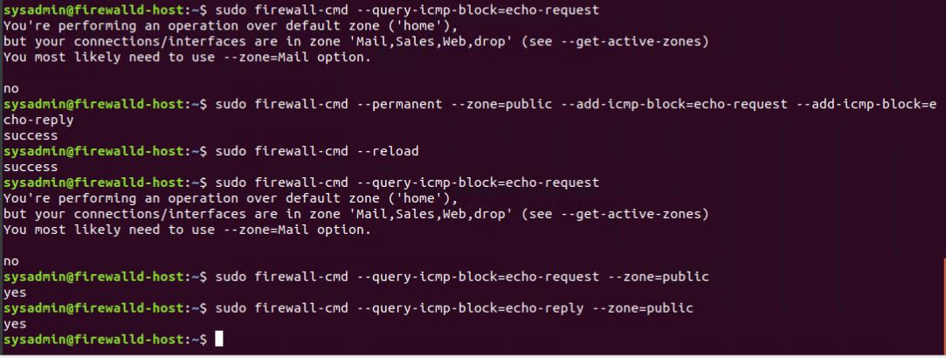

***Dan then decides to triple check

$ sudo firewall-cmd --zone=public --list-all
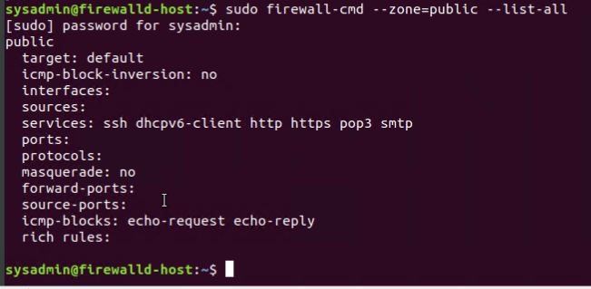

Dang it, there’s no interface for public. I bet I screwed up earlier by using P instead of p.
***Scrolls up again and checks. More disgusted head shaking ensues.

$ sudo firewall-cmd --permanent --zone=public --change-interface=eth0

$ sudo firewall-cmd --reload

$ sudo firewall-cmd --zone=public --list-all
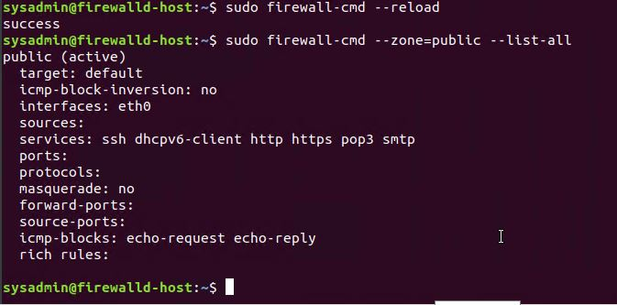
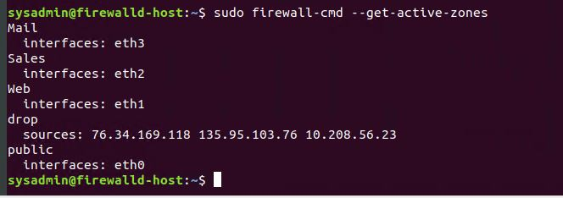

and now to put the rich rule in the right place:

$ sudo firewall-cmd --zone=public --permanent --add-rich-rule=’ rule family=”ipv4” source address=”138.138.0.3” reject’

$ sudo firewall-cmd --reload

$ sudo firewall-cmd --zone=public --list-all
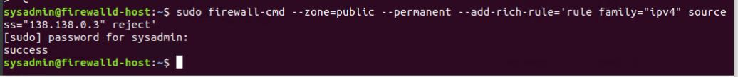
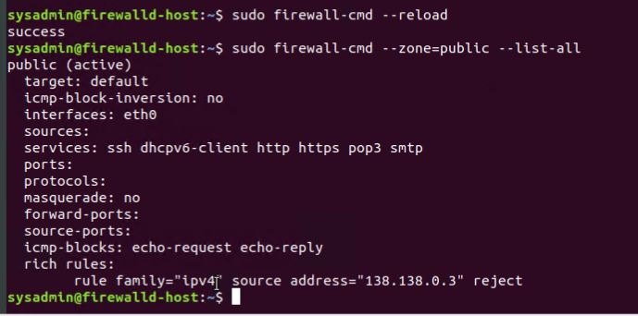
Congratulations! You have (finally) successfully configured and deployed a fully comprehensive `firewalld` installation, and learned to pay much closer attention to case. a single capitalized letter made this whole exercise screwy. can’t believe it took me that long to figure out. sheesh. To remove the useless accidental “Public” zone i created I’d manually delete it from the firewalld config file in /etc using nano.

---

### Part 3: IDS, IPS, DiD and Firewalls

Now, we will work on another lab. Before you start, complete the following review questions.

#### IDS vs. IPS Systems

1. Name and define two ways an IDS connects to a network.

Answer 1: Network TAP

Answer 2: SPAN/Mirrored Port

2. Describe how an IPS connects to a network.

Answer: Physically connects inline behind the firewall

3. What type of IDS compares patterns of traffic to predefined signatures and is unable to detect Zero-Day attacks?

Answer: Signature based

4. Which type of IDS is beneficial for detecting all suspicious traffic that deviates from the well-known baseline and is excellent at detecting when an attacker probes or sweeps a network?

Answer: Anomaly based

#### Defense in Depth

1. For each of the following scenarios, provide the layer of Defense in Depth that applies:

1. A criminal hacker tailgates an employee through an exterior door into a secured facility, explaining that they forgot their badge at home.

Answer: Physical

2. A zero-day goes undetected by antivirus software.

Answer: Application, or Perimeter if using a NGFW (because they are able to run antivirus software)

3. A criminal successfully gains access to HRâ€™s database.

Answer: Data

4. A criminal hacker exploits a vulnerability within an operating system.

Answer: Host

5. A hacktivist organization successfully performs a DDoS attack, taking down a government website.

Answer: Network

6. Data is classified at the wrong classification level.

Answer: Policy, procedures, and awareness

7. A state sponsored hacker group successfully firewalked an organization to produce a list of active services on an email server.

Answer:Perimeter

2. Name one method of protecting data-at-rest from being readable on hard drive.

Answer:Encryption

3. Name one method to protect data-in-transit.

Answer:Encrypted vpn connection, or a stagecoach with well armed gunslingers YEEHAW

4. What technology could provide law enforcement with the ability to track and recover a stolen laptop.

Answer:Preinstalled geolocation programs, tracking the machine’s ip through google/apple/dropbox/social media accounts and locating the networks that it connects with, depending on machine configuration possibly tunneling in through open ports and essentially hacking the stolen machine to retrieve location information. This only works if the thief is merely a thief and not a person with technical knowhow. if they never power on the machine, or replace the NIC, or modify it in such a way that it shows up as an entirely different machine then LE might be SOL. Most likely scenario is that the person will be caught due to using tinder or instagram. I suppose some kind of GPS tracking system with its own battery could be installed somewhere in the case, but that seems pretty extreme for a mid-level executive at Bob’s Sporting Goods Inc.

5. How could you prevent an attacker from booting a stolen laptop using an external hard drive?

Answer: The best method is obviously not to have your laptop stolen. Disable booting from external devices, encrypt disk(s) and require a hardware key, set a bios password… aside from the nuclear “mission impossible” type solution of “this laptop will self destruct in 5...4… a motivated attacker will gain access. to protect data a remote wipe might work, but thorough data destruction takes a reaaaaaally long time. the attacker could always pull the battery immediately, then the wireless card. maybe a secret hidden self-powered module within the machine that triggers if the cmos circuit is broken and upon activation ignites a tiny bit of magnesium embedded in a mixture of ferrous oxide and aluminum powder. seems risky though. In the event of failure it could change from laptop to a lapHOT, and probably would violate laws all the way up and through the patriot act.

#### Firewall Architectures and Methodologies

1. Which type of firewall verifies the three-way TCP handshake? TCP handshake checks are designed to ensure that session packets are from legitimate sources.

Answer: Circuit Level Firewall/Proxy

2. Which type of firewall considers the connection as a whole? Meaning, instead of looking at only individual packets, these firewalls look at whole streams of packets at one time.

Answer: Stateful Firewall

3. Which type of firewall intercepts all traffic prior to being forwarded to its final destination. In a sense, these firewalls act on behalf of the recipient by ensuring the traffic is safe prior to forwarding it?

Answer: Proxy Firewall

4. Which type of firewall examines data within a packet as it progresses through a network interface by examining source and destination IP address, port number, and packet type- all without opening the packet to inspect its contents?

Answer: Stateless Firewall

5. Which type of firewall filters based solely on source and destination MAC address?

Answer: Mac Layer Firewall

